# Wayback Page Locking Filter

The Wayback locking filter allows only one session to access a page at a time. The page URL is locked against the session id.

Pages are released when the user logs out or at midnight - when all locked pages for all sessions are released via a quartz job.

Individual sessions may also be removed using an administration page (a special URL).

## Special URLs

The current pages locked by the filter can be viewed in the page: **http://<host>:8080/wayback/pages/maintainSessions..jsp**

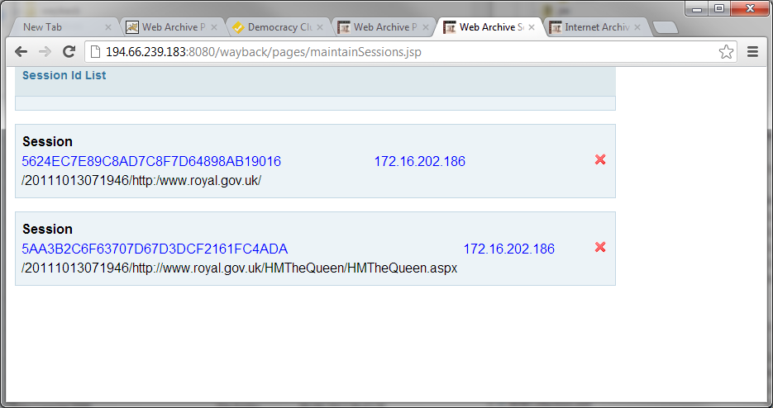

The screen above show Sessions, the related IP address and all the pages that are locked by the session.

Page locks for a session can be removed by clicking the red ‘x’.

A user can log off and release their current page locks by calling the URL: **http://<host>:8080/wayback/logoff**

## URL Filtering

URLs are currently filtered for locking by a number of different criteria, including:

1. Only pages with an Accept header of **text/html,application/xhtml+xml,application/xml;q=0.9,*/*;q=0.8** are locked by the filter;
2. HTTP Get calls;
3. The exceptions are URLs constructed by Wayback which contain **_/http://** i.e. 20111013072811im_/http://www.royal.gov.uk/TemplateAssets/pic-rss_small.gif;
4. and media suffixes (such as .jpg and .png) which are defined in the filter.properties file.